Create a PPK file to login with ssh

ARPLA - GI Architecture and Platforms

Exported on 28 Apr 2023

Table of Contents

1 OR 5

2 2nd way to configure the 6

3 Log with ppk file using differnet Tool 9

4 Using Putty 10

5 Using mobaxterm 11

6 Using WinScp 12

1. Open the **PuTTYgen** program.
2. Select the Type of key to generate, select **RSA**.
3. Click the **Generate** button.
4. Move your mouse in the area below the progress bar. When the progress bar is full, PuTTYgen generates your key pair.
5. Type a passphrase (Password) in the **Key passphrase** field. Type the same passphrase in the **Confirm passphrase** field.
6. Click the **Save private key** button & give **the name** to save the private key.  You must save the private key. You will need it to connect to your machine.
7. Right-click in the text field labeled **Public key for pasting into OpenSSH authorized_keys file** and choose **Select All** **& Copy.**

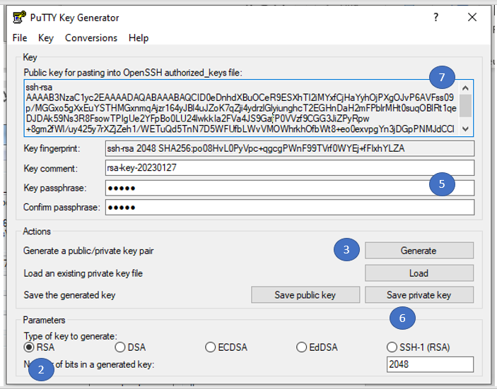

8. Add this key in **authorized_keys** for **(e.g. /root/.ssh/authorized_keys**). Replace the user with **your user** location.

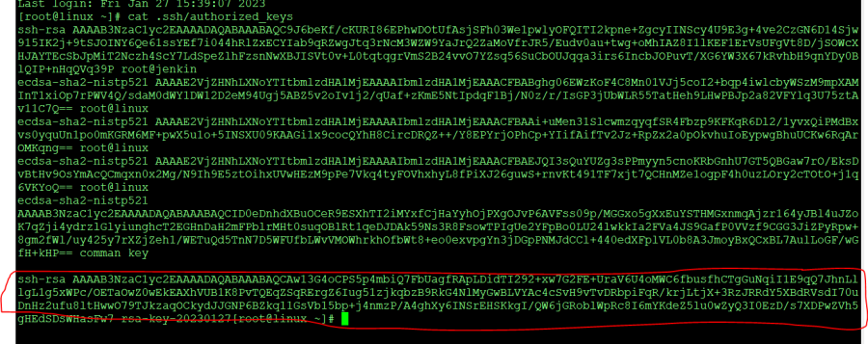

# OR

# 2nd way to configure the

* Create a file and add below content.

**touch create.sh**  
**#!/bin/bash**  
**read -p "Enter your Q-Number : " empid**  
**ssh-keygen -f ~/.ssh/$empid-key-ecdsa -t ecdsa -b 521**

* Change the permission.

**chmod 755 create.sh**

* Execute the shell script.

**./create.s**

* Go to the **.ssh folder** in your home directory and **locate key (not .pub key**) and download that they in your windows system.



* Open the **puttygen** and click on **load key** select the key which you **downloaded**.

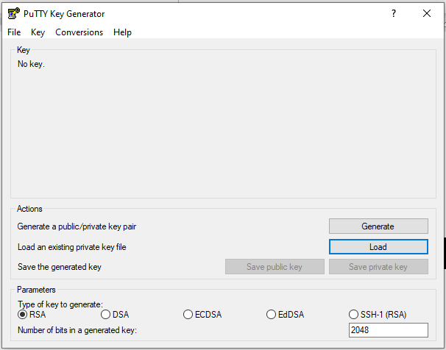

* Add the **password** which you entered at the time of key creation and click ok.

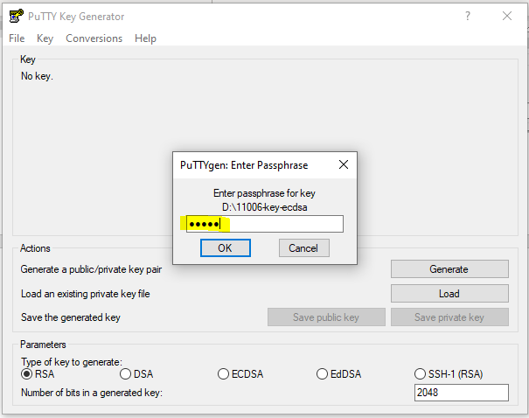

* Click on **Save private key** and enter the **name and save**. You need this key to login later.

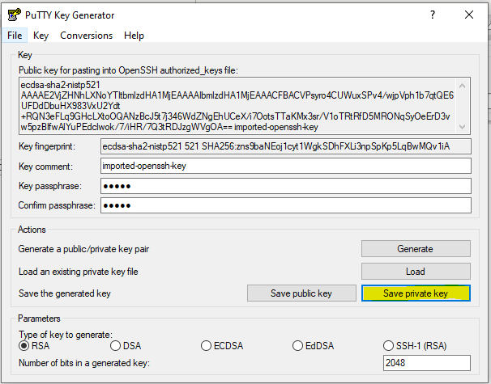

* Once you save the key right click on **Public key** **for pasting** and **copy that key.**

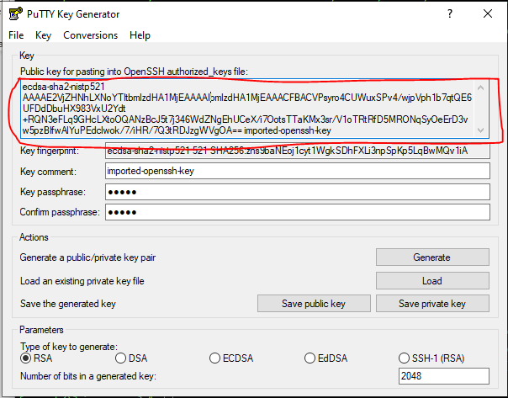

* Add this key in the **authorized_keys** **(e.g./root/.ssh/authorized_keys)** this file is present in your home directory.

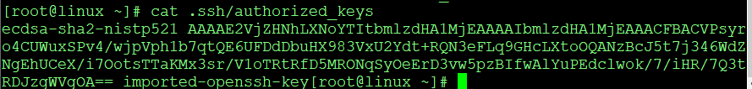

# Log with ppk file using differnet Tool

* **Puttuy**
* **mobaxterm**
* **Winscp**

# Using Putty

* **Open putty and enter the username & Host Name**
  + **qqtdev@**[**ltawstegXXX.gi**](http://ltawsteg355.gi)**-dev.eu-central-1.aws.cloud.bmw  (Your System Name)**

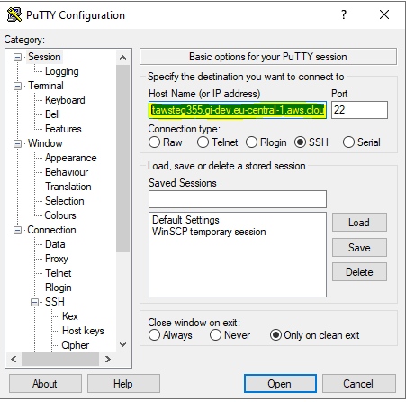

* **From left side pan go to the**
  + **Connection → SSH → Auth → click on browse**
  + **And give the path XXX.ppk file (Your created .ppk file)**

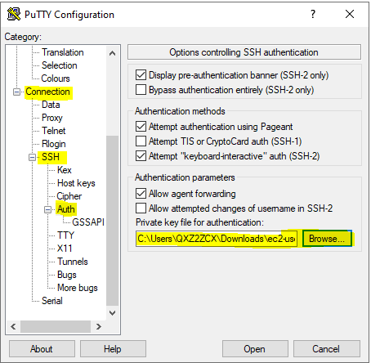

* Click on **Open** after that session will start if it will ask password then **enter the password you set at the time of .ppk file creaion**.

# Using mobaxterm

1. Open **Mobaxterm** and click on **session**
2. Click on **ssh**
3. Enter your **system hostname (e.g.** [**ltawstegXXX.gi**](http://ltawsteg355.gi)**-dev.eu-central-1.aws.cloud.bmw** )
4. Check the box and enter the **UserName (e.g. ec2-user OR qqtdev)**
5. Check the box and locate the your **created XXX.ppk file**
6. Click on **Ok**
7. **It will login if asked for password enter the password password you set at the time of .ppk file creaion**.

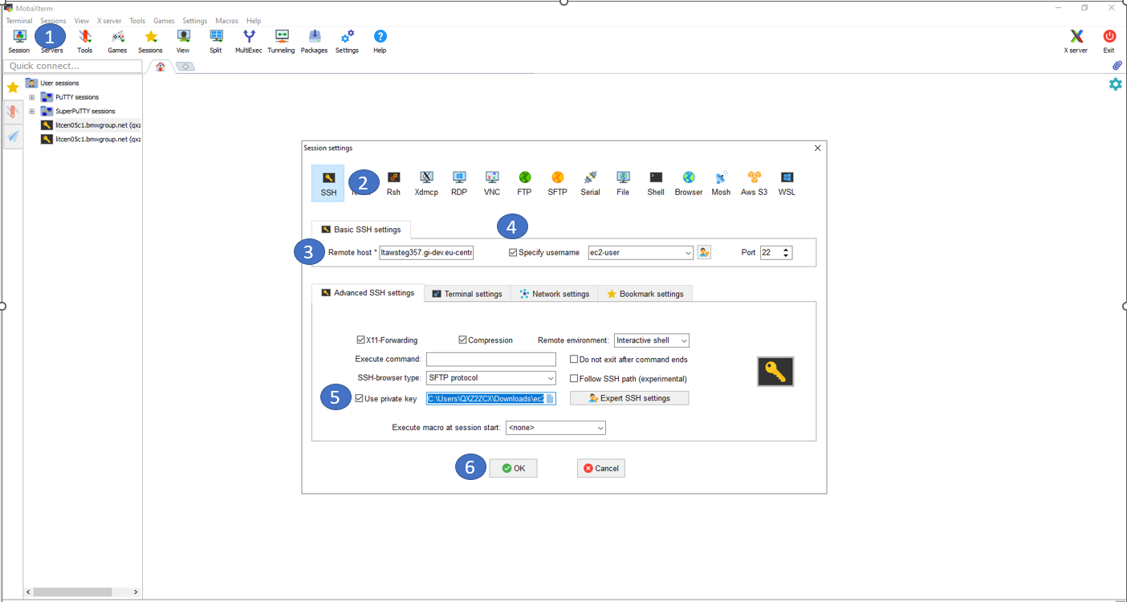

# Using WinScp

1. Open the WinScp and Click on new Site
2. In the Hostname field enter your system hostname **(e.g.** [**ltawstegXXX.gi**](http://ltawsteg355.gi)**-dev.eu-central-1.aws.cloud.bmw )**
3. In the Username field enter the **your username.**
4. Then **c**lick on **Advanced button.**
5. Then new tab will open in that **Click on Authentication.**
6. **Browse your ppk file and add it.**
7. **Then click on OK**
8. **Then click on Login button.**
9. **if it will ask for password then enter tha password you set at the time of .ppk file creaion**.

